



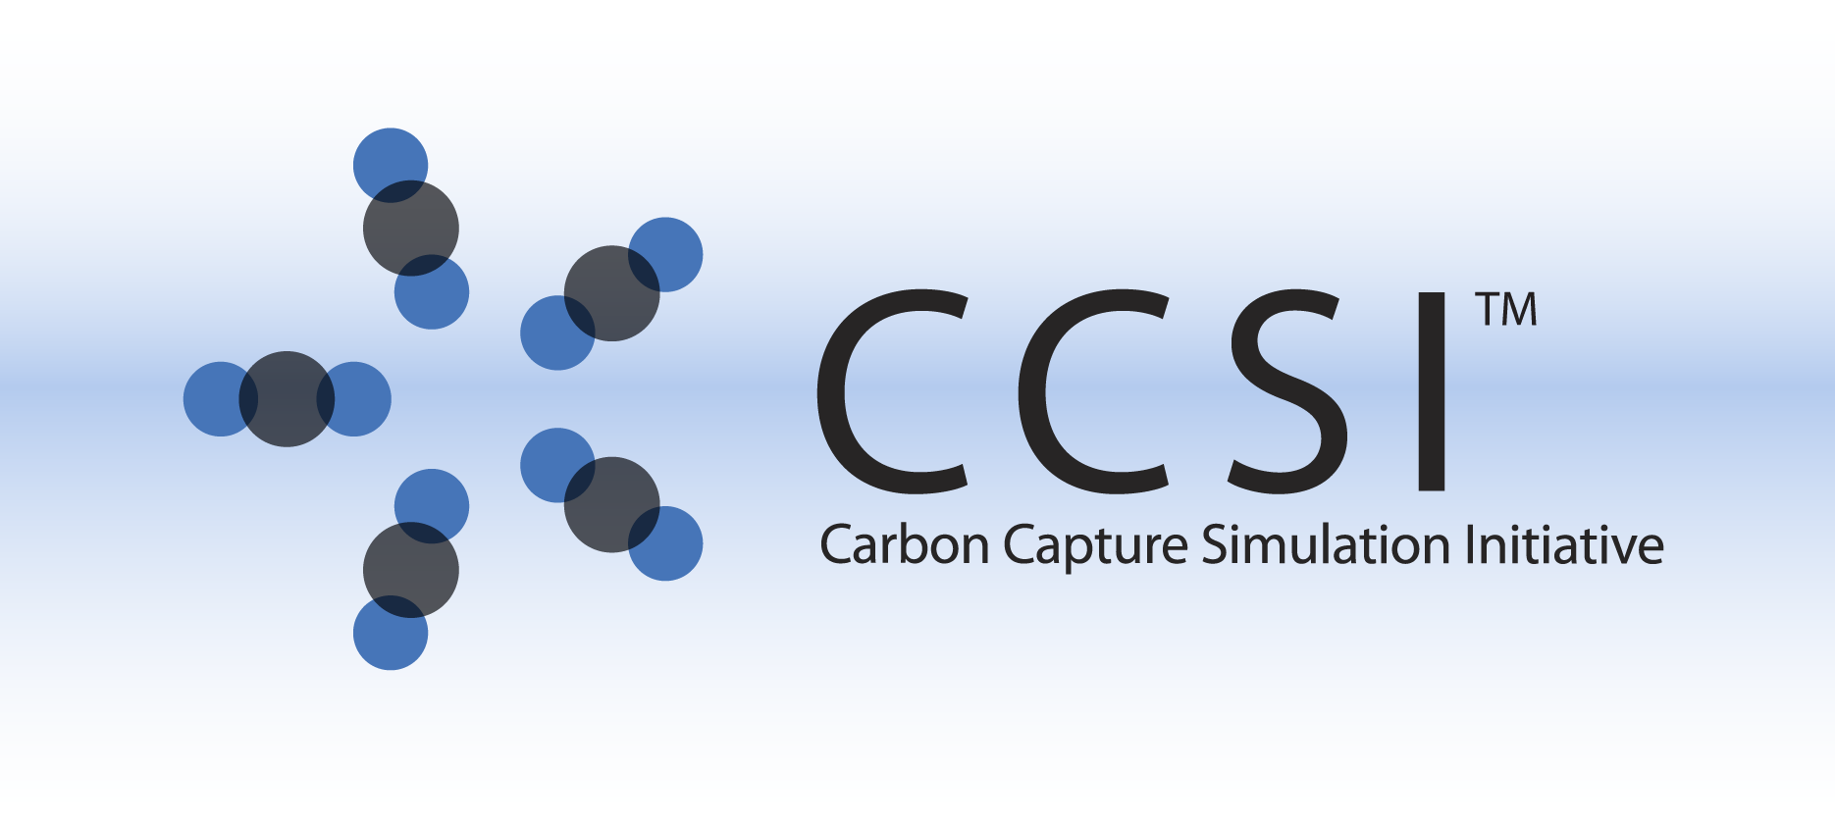

Dynamic Reduced Order Models for the solid sorbent Bubbling Fluidized Bed

(BFB-D-ROM)

User Manual

Version 2.0.0

March, 2018

Copyright (c) 2012 - 2018

**Copyright Notice**

Dynamic Reduced Order Models for the solid sorbent Bubbling Fluidized Bed (BFB-D-ROM) was produced under the DOE Carbon Capture Simulation Initiative (CCSI), and is copyright (c) 2012 - 2018 by the software owners: Oak Ridge Institute for Science and Education (ORISE), Los Alamos National Security, LLC., Lawrence Livermore National Security, LLC., The Regents of the University of California, through Lawrence Berkeley National Laboratory, Battelle Memorial Institute, Pacific Northwest Division through Pacific Northwest National Laboratory, Carnegie Mellon University, West Virginia University, Boston University, the Trustees of Princeton University, The University of Texas at Austin, URS Energy & Construction, Inc., et al.. All rights reserved.

NOTICE. This Software was developed under funding from the U.S. Department of Energy and the U.S. Government consequently retains certain rights. As such, the U.S. Government has been granted for itself and others acting on its behalf a paid-up, nonexclusive, irrevocable, worldwide license in the Software to reproduce, distribute copies to the public, prepare derivative works, and perform publicly and display publicly, and to permit other to do so.

**License Agreement**

Dynamic Reduced Order Models for the solid sorbent Bubbling Fluidized Bed (BFB-D-ROM) Copyright (c) 2012 - 2018, by the software owners: Oak Ridge Institute for Science and Education (ORISE), Los Alamos National Security, LLC., Lawrence Livermore National Security, LLC., The Regents of the University of California, through Lawrence Berkeley National Laboratory, Battelle Memorial Institute, Pacific Northwest Division through Pacific Northwest National Laboratory, Carnegie Mellon University, West Virginia University, Boston University, the Trustees of Princeton University, The University of Texas at Austin, URS Energy & Construction, Inc., et al. All rights reserved.

Redistribution and use in source and binary forms, with or without modification, are permitted provided that the following conditions are met:

1. Redistributions of source code must retain the above copyright notice, this list of conditions and the following disclaimer.
2. Redistributions in binary form must reproduce the above copyright notice, this list of conditions and the following disclaimer in the documentation and/or other materials provided with the distribution.
3. Neither the name of te Carbon Capture Simulation Initiative, U.S. Dept. of Energy, the National Energy Technology Laboratory, Oak Ridge Institute for Science and Education (ORISE), Los Alamos National Security, LLC., Lawrence Livermore National Security, LLC., the University of California, Lawrence Berkeley National Laboratory, Battelle Memorial Institute, Pacific Northwest National Laboratory, Carnegie Mellon University, West Virginia University, Boston University, the Trustees of Princeton University, the University of Texas at Austin, URS Energy & Construction, Inc., nor the names of its contributors may be used to endorse or promote products derived from this software without specific prior written permission.

THIS SOFTWARE IS PROVIDED BY THE COPYRIGHT HOLDERS AND CONTRIBUTORS "AS IS" AND ANY EXPRESS OR IMPLIED WARRANTIES, INCLUDING, BUT NOT LIMITED TO, THE IMPLIED WARRANTIES OF MERCHANTABILITY AND FITNESS FOR A PARTICULAR PURPOSE ARE DISCLAIMED. IN NO EVENT SHALL THE COPYRIGHT OWNER OR CONTRIBUTORS BE LIABLE FOR ANY DIRECT, INDIRECT, INCIDENTAL, SPECIAL, EXEMPLARY, OR CONSEQUENTIAL DAMAGES (INCLUDING, BUT NOT LIMITED TO, PROCUREMENT OF SUBSTITUTE GOODS OR SERVICES; LOSS OF USE, DATA, OR PROFITS; OR BUSINESS INTERRUPTION) HOWEVER CAUSED AND ON ANY THEORY OF LIABILITY, WHETHER IN CONTRACT, STRICT LIABILITY, OR TORT (INCLUDING NEGLIGENCE OR OTHERWISE) ARISING IN ANY WAY OUT OF THE USE OF THIS SOFTWARE, EVEN IF ADVISED OF THE POSSIBILITY OF SUCH DAMAGE.

You are under no obligation whatsoever to provide any bug fixes, patches, or upgrades to the features, functionality or performance of the source code ("Enhancements") to anyone; however, if you choose to make your Enhancements available either publicly, or directly to Lawrence Berkeley National Laboratory, without imposing a separate written license agreement for such Enhancements, then you hereby grant the following license: a non-exclusive, royalty-free perpetual license to install, use, modify, prepare derivative works, incorporate into other computer software, distribute, and sublicense such enhancements or derivative works thereof, in binary and source code form. This material was produced under the DOE Carbon Capture Simulation

**Revision Log**

| Version Number | Release Date | Description |
| --- | --- | --- |
| 2015.10.0 | 10/16/2015 | 2015 October IAB Release – This version includes two dynamic reduced order models for the bubbling fluidized bed adsorber model, with minor changes in the model equations. |
| 2.0.0 | 03/31/2018 | Initial Open Source release |

Table of Contents

BFB-D-ROM 1

1.0 Introduction 1

2.0 Methodology 1

3.0 Test Tutorial 2

3.1 Dynamic Simulation 2

3.2 Comparison of Simulation Cost and Accuracy 5

4.0 References 6

List of Figures

Figure 14: Dynamics of percent CO2 removed for disturbances in flue gas flowrate, temperature, and solid temperature. 3

Figure 15: Dynamics of sorbent loading for disturbances in flue gas flowrate, temperature, and solid temperature. 4

List of Tables

Table 8: Dynamic Simulation Results 5

To obtain support for the products within this package, please send an e-mail to   
[ccsi-support@acceleratecarboncapture.org](mailto:ccsi-support@acceleratecarboncapture.org).

BFB-D-ROM

1. Introduction

This documentation introduces the Dynamic Reduced Order Models (D-ROM) for the solid sorbent Bubbling Fluidized Bed (BFB) Adsorber Model that has been developed within the Carbon Capture Simulation Initiative (CCSI) to simulate the solid sorbent adsorption unit in carbon capture processes. The dynamic reduced models are developed to enable fast and accurate dynamic simulation of the BFB reactor. It can provide accurate prediction within large operation ranges, as the rigorous BFB process model, with improved computational efficiency. The dynamic reduced models can give fast prediction of process transient behavior and is suitable for simulation-based time-critical applications such as advanced process control and optimization. It could also be used for applications which require a large number of simulations, such as uncertainty qualification.

This document introduces the general methodology applied to the model reduction and provides a tutorial to use the reduced models for the BFB adsorber. The detailed description about this one-dimensional Partial Differential Equations (PDE) process model is in [1] – [3]. The base model used to generate the reduced models is version 5.2.2 of the BFB process model, which was released in October 2014. Based on that, minor changes have been made to the base BFB model. For example, all the Aspen property functions are replaced by correlation equations. A more detailed description of model updates, as well as the development of reduced models can be found in [4]. The developed models are implemented in Aspen Custom Modeler® (ACM, Aspen Technology, Inc.). ACM 8.4 or higher version is required to be installed to run the models.

1. Methodology

Model reduction seeks to generate models with a reduced number of equations and less simulation time, which maintain nearly the same response characteristics, to replace the original complex systems. Model reduction methods have been applied to generate two reduced models from a temporal and spatial aspect. These techniques are general approaches which can be applied to model reduction of other distributed parameter systems.

For temporally dynamic reduced models, the null-space projection method [5] is used to reduce the reaction kinetics of the adsorption process. The underlying idea is to separate the fast and slow components in a Differential Algebraic Equations (DAE) system by describing the fast components with algebraic equations capturing their quasi-steady states. As a result, the reformulated system becomes less stiff but with the same asymptotic behavior. Based on the simulation results and kinetics data of the rigorous model, the reaction rate of water physisorption is much faster than the other reactions. A   
quasi-steady state approximation was performed by assuming that the water physisorption reaction is always at equilibrium.

For spatially dynamic reduced models, spatial orthogonal collocation on finite elements is applied to discretize the partial differential equations. A certain type of high order polynomial -Lagrange polynomials are used to approximate the states. The approximation using this polynomial has a desirable property that the polynomial is the same as the true solution at the collocation points. Shifted Radau roots are chosen as collocation points. The collocation method is high orders compared with the finite difference method [6]. Thus it needs fewer discretization points, which can reduce the model size and simulation cost. By studying the spatial profiles of the rigorous BFB model, an unevenly distributed finite element scheme is introduced to further reduce the size of the reduced model.

1. Test Tutorial

This section provides tutorials to perform the simulation of the Dynamic Reduced Model Adsorber BFB Model. These models were developed using ACM v8.4.

* 1. Dynamic Simulation

No controller has been used to maintain the overall percent CO2 removed [3]. One case study to test the performance of the Dynamic Reduced Order Models is as follows. In the case study, multiple disturbances are introduced and the simulation cost and key parameters accuracy of the reduced model and original model are compared.

The original BFB Model is named “BFB_original_model.” The model is treated as the base model for simulation cost and model accuracy comparison. The temporally dynamic reduced BFB Model is named “BFB_temporally_drom” while the spatially reduced BFB Model is named “BFB_spatially_drom.”

The following steps/notes can be followed to run/modify the adsorber model with open-loop control:

1. Double-click the ACM input file “BFB_original_model.acmf.”
2. Load the snapshot of the Steady_state_solution to use as a starting point for the dynamic simulations. Click “Snapshot Management” in the menu bar (camera icon), select the snapshot “Steady_state_solution,” and then click “Copy Values.”
3. To run the dynamic simulation, change the “run mode” to “Dynamic” by changing the “run mode” in the menu bar or by clicking “Run” → “Mode” → “Dynamic.”
4. The settings used for the dynamic simulation can be viewed by clicking “Solver Options” in the menu bar. In this example, the integration method used is Implicit Euler. All of the tolerances are kept at the default value of 1e-005.
5. Under “Run Options,” the time units are Seconds to match with the time unit that is used in the model. Under “Communication” → “Time control,” a value of 1 sec is used. This value can be changed, if needed. (**Note:** A small value can slow down the simulation considerably whereas a large value fails to show the dynamics of the fast processes.) To pause the simulation at a specific time, such as at 100 sec, the value in the “Pause at” field located under “Run Options” → “Simulation control” should be changed to “100 sec.” In this example, the simulation pause is at 500s.
6. Five disturbances are introduced in task files under the “FlowSheet” in the “Explorer” panel. The first disturbance is introduced by a script file, “disturbance1,” where a ramp change in the valve opening of the input gas occurs from 85% to 70%. The script file is activated by default. To deactivate the script, double-click the task “disturbance1.” In addition, other disturbances in the flue gas flow, temperature, and solid temperature are introduced in disturbance two–five to test the model’s dynamic response.
7. A plot, “CO2_removal,” is located under “FlowSheet” in the “Explorer” panel. This plot shows the transients of percent CO2 removed. To create an additional plot, select “New form” from the “Menu” and then name the plot. Select the variable of interest by double-clicking a “stream” or an “equipment object,” clicking the “variable,” and then dragging it to the “Y-axis.” (**Note:** There is no data to show in any of the plots until the simulation is run. However, the plots can be configured before running the simulation. Any variable that has been selected for plotting is automatically saved in history by ACM. In addition, another plot, “loading,” is located under “FlowSheet” that represents the solid sorbent total loading, which is also an important variable for the adsorber model.)
8. To edit a plot in ACM, right-click the “plot” and then select “Properties.” Select the run time to change the range of the time axis. Select “Axis” to change the range of the process variable(s) in the plot. The title of the plot and labels of the axes can be changed by clicking “Label” and then entering the text as desired.
9. The simulation can be run for a specified time (500 sec in this example) by clicking “Run” under the “Run” menu or by clicking “Play.” The results can be plotted in ACM or the data can be exported to Microsoft® Excel® for plotting. The plots of the CO2 capture percent and sorbent loading for the original BFB Model are shown in Figures 14 and 15.

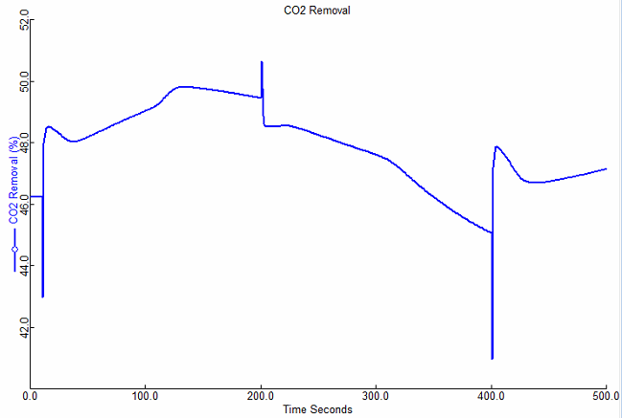

Figure : Dynamics of percent CO2 removed for disturbances  
in flue gas flowrate, temperature, and solid temperature.

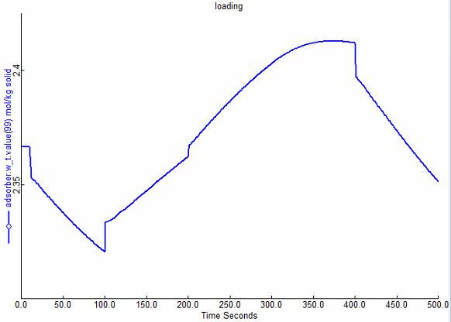

Figure : Dynamics of sorbent loading for disturbances  
in flue gas flowrate, temperature, and solid temperature.

For temporally and spatially reduced model, dynamic simulations can be conducted following Steps 3–9.

**Note:** In the spatially reduced model, the orthogonal collocation is used on the finite elements scheme to discretize the partial differential equations. The states are represented in arrays. For the current model, 12 finite elements with three collocation points within each element are used. For example, the state temperature T at the bottom boundary is represented by T(0,0) and the temperature at the top boundary is denoted by T(12,3). The total number of finite elements is represented by variable M, which can be specified by the user. The overall spatial region is divided into two sub-regions. The spatial derivatives of states are relatively large within the lower region, thus a relatively dense set of collocation points are used in the lower region. The length of the lower region is Lb1, and the number of finite elements in the lower region is M_b. The values for these parameters are decided by studying the spatial profiles of the states in the original model. In current version of reduced model, the length of lower region is 0.5 m and 2 finite elements are placed in the lower region. The following steps are needed to change the parameters in the spatially reduced model:

1. Double-click the ACM input file “BFB_spatially_drom.acmf.”
2. Load the snapshot of the Steady_state_solution to use as a starting point for the steady state simulation. Click “Snapshot Management” in the menu bar (camera icon), select the “snapshot Steady_state_solution,” and then click “Copy Values.”
3. To change the parameters such us the number of finite elements, right-click the reactor icon, select “Form,” and then click the “Number_of_finite_elements table.” The value of M can be changed in this table. For example, the value of M is specified to 13.
4. Right-click the reactor icon, select “Scripts,” and then click the “IPsolve” script. The script automatically runs to obtain the new steady state solution for a different number of finite elements.

After obtaining the new steady state solution, the dynamic simulation can be performed. The first step is to change the run mode to dynamic by following Step 3. Then change the specifications for the initial value since the number of differential equation is changed. From the “Tools” menu, select “Specification Analysis,” and then select “Set spec of all states variables to RateInitial (Steady State),” which makes the dynamic simulation start from the steady state. The dynamic simulation can now be performed by following Steps 4–9.

**Note**: If the increment of M is too large, running the IPsolve script may be slow. Increase M with a small increment and then repeat Steps 10–13 to find the new steady state solution.

The dynamic simulation results of the original and reduced models are summarized in the following section.

* 1. Comparison of Simulation Cost and Accuracy

The dynamic simulations were performed on an Intel® i7-3770 3.40GHz personal computer. Computational costs are subject to change for different hardware. But it is expected to have a similar percentage of reduction in simulation time (Table 8).

From the case study, the temporally reduced model can achieve a 35% simulation time reduction while the spatially reduced model can achieve a 60% reduction. Both the temporal and spatial Dynamic Reduced Order Models for the BFB adsorber run faster than the original model while maintaining reasonable accuracy. They can be easily used for other simulation-based applications and help improve computational efficiency.

Table : Dynamic Simulation Results

|  | Simulation Time(s) | MRE1(%) | MSE1(%2) | MRE2(%) | MSE2(mol2/kg2) |
| --- | --- | --- | --- | --- | --- |
| BFB1 | 168 |  |  |  |  |
| BFB2 | 111 | 0.25 | 3.84e-5 | 0.01 | 4.14e-8 |
| BFB3 | 67 | 0.85 | 0.06 | 0.13 | 9.86e-6 |

BFB1 – Original BFB Adsorber

BFB2 – Temporally Dynamic Reduced Model

BFB3 – Spatially Dynamic Reduced Model

MRE – Maximum Relative Error

MSE – Mean Squared Error

1 – CO2 Removal Percent

2 – Sorbent Loading

1. References

[1] Lee, A., Mebane, D.S., Fauth, D.J., and Miller, D.C., “A Model for the Adsorption Kinetics of CO2 on Amine-Impregnated Mesoporous Sorbents in the Presence of Water,ˮ Pittsburgh Coal Conference, 2011.

[2] Lee, A., and Miller, D.C., “A One-Dimensional (1-D) Three-Region Model for a Bubbling Fluidized-Bed Adsorber,ˮ *Industrial & Engineering Chemistry Research*, 2013, 52 (1), 469-484.

[3] Modekurti, S., Bhattacharyya, D., and Zitney, S., “Dynamic Modeling and Control Studies of a Two-Stage Bubbling Bed Adsorber-Reactor for Solid-Sorbent CO2Capture,ˮ *Industrial & Engineering Chemistry Research*, 2013, 52, 10250-10260.

[4] Yu, Mingzhao, David C. Miller, and Lorenz T. Biegler. “Dynamic reduced order models for simulating bubbling fluidized bed adsorbers.” *Industrial & Engineering Chemistry Research* 54.27 (2015): 6959-6974.

[5] Nie, Yisu, et al. “Reactor modeling and recipe optimization of polyether polyol processes: Polypropylene glycol.” *AIChE Journal* 59.7 (2013): 2515-2529.

[6] Biegler, Lorenz T. Nonlinear programming: concepts, algorithms, and applications to chemical processes. Vol. 10. SIAM, 20